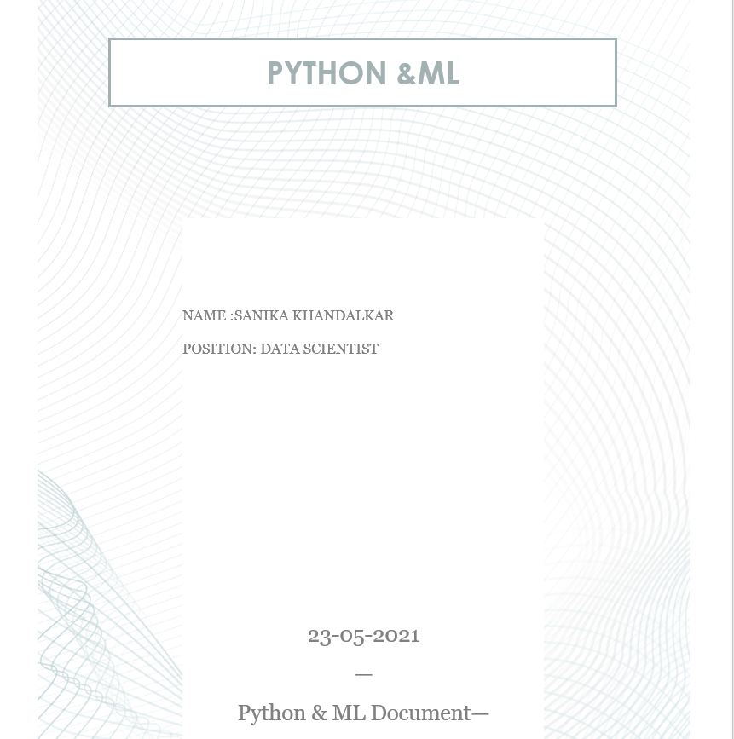

INTRODUCTION

This assignment consist of few python and well as few Machine learning program..

Theory as well as snippets of each and every code will be mentioned.

Question no.1

**Write a Python Program to compute the multiplication of two matrices and then print it.**

Answer with Code:

a. As we know, Matrix multiplication is an operation that takes two matrices as input and produces a matrix with the help of multiplying the first matrix to the second matrix.

b. Here, we have taken (3*2) matrix, now for the following process, we need to execute code that will give us the product of the two matrices.

c. Also, we need to look after that the number of 1 matrix is equal to the number of 2 matrices. which will eventually lead to an error-free output.

code:

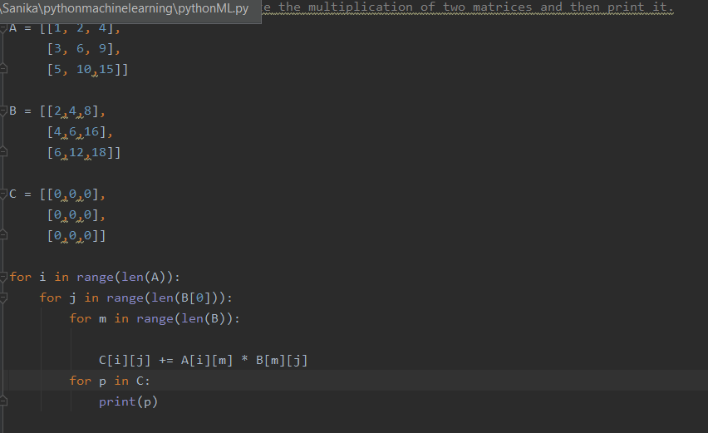

Output:

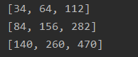

Question no.2

**Write a Python program to find yesterday, today, and tomorrow's date**.

Answer with code:

1. We understand that here, we need to execute a code that shows up the date considering today's yesterdays and tomorrows.
2. In PyCharm, first we need to import 'datetime'
3. Then we need to write few lines of code considering our program

code:

The output should list the current date of today and with the help of today's, it should retrieve yesterday's and tomorrow's date simultaneously.

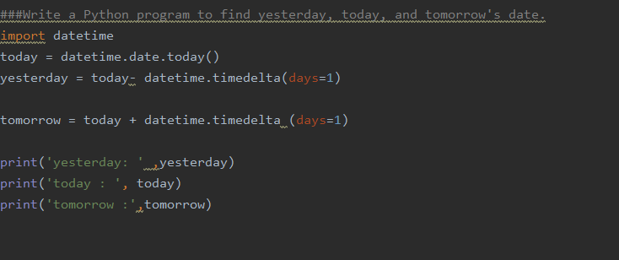

Output:

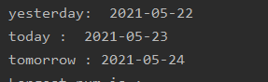

Question no.3

**Write a Python program to find Nth largest number in a list.**

Answer and code:

Now here we need to find out the Nth largest number in the list with the

help of sort() method

a. Initially, we first need to arrange the unsorted array by giving a variable name.

b. Also sort() functions sort list in ascending order considering the list.

c.. Now when sorting takes place if the N is 1, then return the last element, otherwise return array[n – N], where n is the size of the array.

d. Thus after this operation we retrieve the output where we get the Nth largest number in the list.

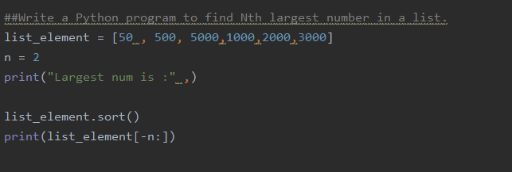

Output:

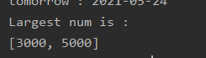

Question no. 4

Explain the NLTK module in python and execute each step involved.

Answer with code:

What is NLP?

1. Natural Language processing, well I believe NLP is one of the advanced science technology.
2. NLP is brought up by humans where a machine understands and interacts with a human. And all this was possible because of the powerful tool, Big data, Advanced processors, upgraded algorithms, etc.
3. As we know machine doesn't understand language what human speaks example Hindi, English, etc. Here machine only understands its machine code, Which means it only knows hundreds of zeros and the ones and that produce actions and not with words.

Mechanism of NLP (Example)

.Herewith the help of the example lets us understand the mechanism of the Natural Language processing let's talk how Alexa takes or read the command and display output with 5 sec. What all does happens in the background?

well, When you speak or give them a command, the device gets activated.

It Understands the intent in the comment, and starts to executed action, and thus provided feedback in a well-formed English sentence, all in the space of about five seconds.

And all these two ways interaction between the human and machine and how the machine reacts to it and gives whole new and accurate output is done by NLP also with the help of AI, Machine Learning and deep learning

Now,

What is NLTK?

Well NLTK stands for Natural Language Toolkit. It is one of the most powerful elements which contains libraries and also programs that help us understand statistical language processing.

It also contains many packages which help the machine to understand human language and command and thus it gives us accurate output as well

NLP Program with steps:

1. pip install NLP

Here, with the help of this command, NLP gets install and we can start with our further execution

2. import nltk

NLTK helps the PC to investigate, pre-process, and comprehend the composed content.

3.Tokenization

Tokenization is the initial phase in text investigation. The way toward separating a book passage into more modest lumps, for example, words or sentences is called Tokenization.

code:

4.Frequency Distributor

Frequency Distributor helps to execute a program in a graphical representation. by importing Matplotlib library.

5.Stopwords

Stopwords are considered as the commotion in the content. Text may contain stop words, for example, is, am, are, this, a, an, the, and so forth

6.Stemming

Stemming comes from linguistic normalization which helps in which diminishes words to their promise root word or chops off the derivational attaches

7:Lemmatization

Lemmatization decreases words to their base word It changes root word with the utilization of jargon and morphological examination. .Lemmatization is more sophisticated than stemming

8.POS Tagging

The essential objective of Part-of-Speech(POS) labelling is to distinguish the syntactic gathering of a given word. POS Tagging searches for connections inside the sentence and relegates a comparing tag to the word

code:

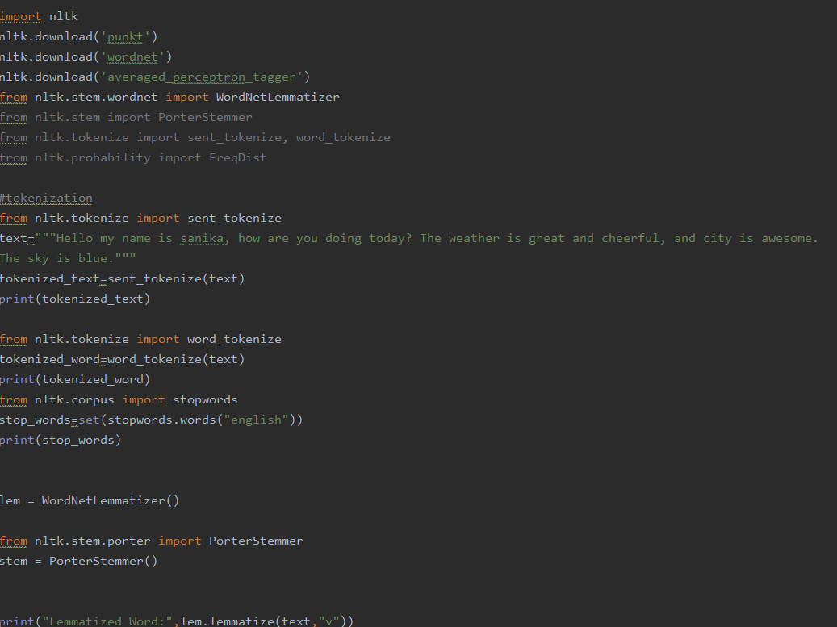

Output:  
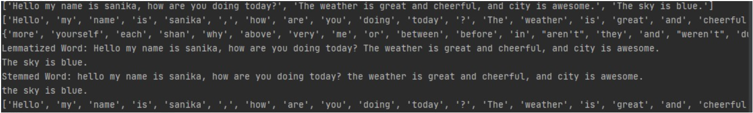

Question no. 5

**What is Convolution Neural Network? Illustrate using python and document the process**.

Answer:

Convolution is the process of taking raw data and generating feature maps from it. Pooling is a type of down sampling that is most commonly used in the form of "max-pooling," in which we pick a region and then take the largest value in that region, which becomes the new value for the whole region. Completely Linked Layers are neural networks in which all nodes are "fully connected." Unlike a regular neural network, the convolutional layers are not fully linked.

* Starting with an image
* We need to convert image into pixels. (Assuming)
* Assuming that each square represents a pixel. Next, for the convolution stage, we'll select a window and look for features within that window.
* For now, we will use single pixel-sized feature in a new feature map, but we will have multiple layers of feature maps in reality

.

* Next will consider a new window, there will be an overlap

.

* Till will cover the entire image we need to do feature map. The feature map is often just more pixel values, though a very simplified one
* Now will start pooling
* Well take 3x3 pooling window
* The most frequent type of pooling is "max pooling," in which we simply take the maximum value in the window and use it as the new value for that region.
* Each stage of convolution and pooling is a hidden layer. Following that comes a completely linked layer, followed by the output layer. The fully connected layer is a conventional neural network (multilayer perceptron) layer, and the output layer is the same

Question no 6.

**Implement NLP analysis of a restaurant review in python**.

Answer with Code:

A . Here we have Dataset for this program. Eventually, with the help of this dataset, we will analyze and predict the accuracy we will retrieve with the help of this program.

B . Also, we will perform Tokenization, Stopwords, data cleaning, pre-processing, confusion matrix, etc. and after applying all this we get a good output

*cnt screenshot whole code that’s attaching starting of the code with output

Code:

* Start of the code

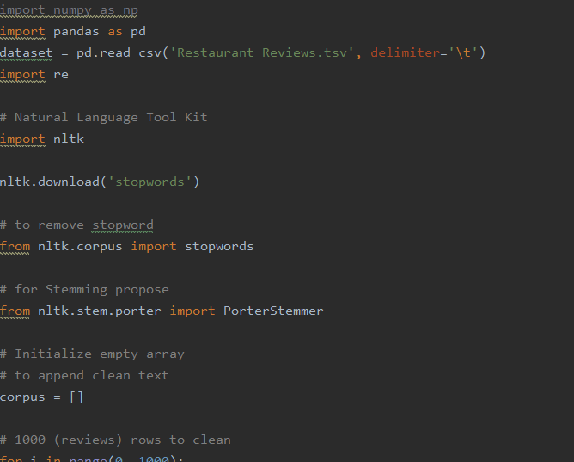

Output:

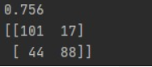

Question no .7

**Create Line Graph, Bar chart, Histograms, Scatter plot, Pie Chart, 3D plots using matplotlib in python**.

Answer with code:

What is meant by Graphical Representation?

a. Graphical portrayal alludes to the utilization of natural outlines to imagine and work on informational indexes.

b. Information is ingested into the graphical portrayal of information programming and afterward addressed by an assortment of images, for example, lines on a line diagram, bars on a bar outline, or cuts on a pie graph, from which clients can acquire more noteworthy understanding than by mathematical investigation alone.

c. Here, we will use one of the most powerful libraries for Data Visualization called Matplotlib

Graphs we plotted are as following:

Line Graph

A line diagram, otherwise called a line plot or line outline, is a chart that utilizes lines to associate individual information focuses showing quantitative qualities throughout a predetermined time stretch.

Code:

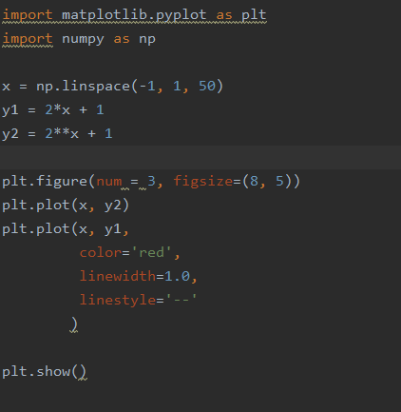

Output:

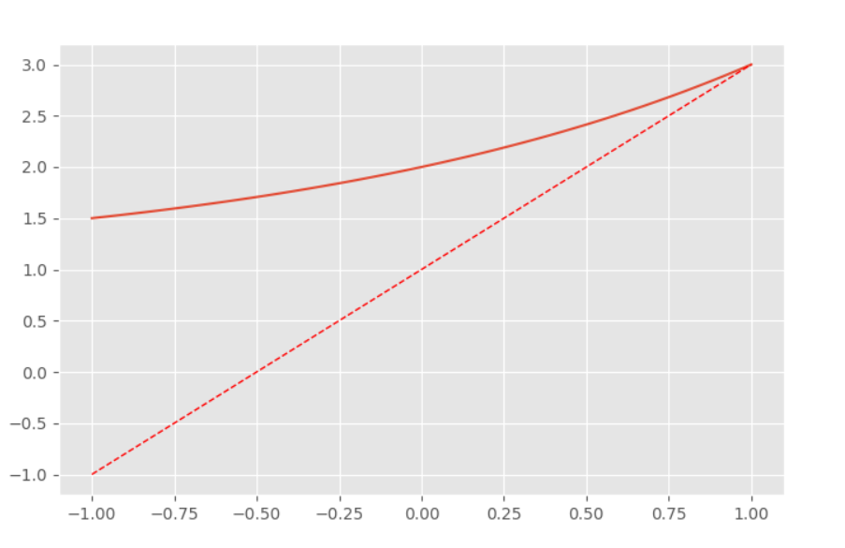

Bar chart

A bar plot or bar outline is a diagram that addresses the class of information with rectangular bars with lengths and statures that is corresponding to the qualities which they address. The bar plots can be plotted on a level plane or in an upward direction.

code: 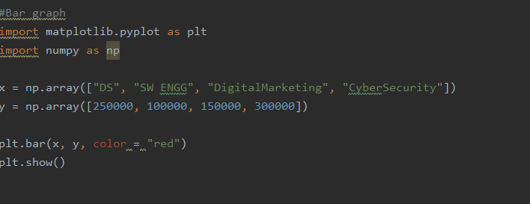

output:

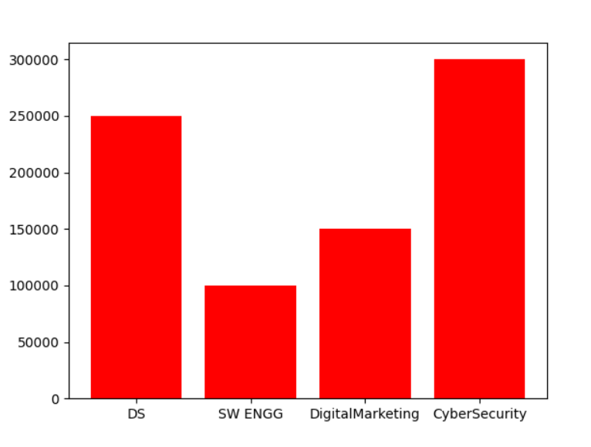

Histogram

A histogram is essentially used to address information given in a type of some groups. It is the precise strategy for the graphical portrayal of mathematical information distribution. It is a kind of bar plot where X-pivot addresses the container ranges while Y-hub gives data about recurrence.

To create a histogram the first step is to create a bin of the ranges, then distribute the whole range of the values into a series of intervals, and count the values

code: 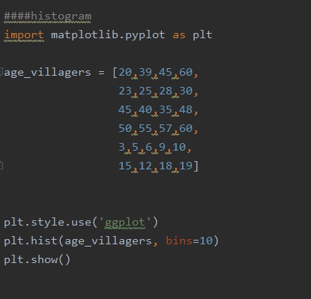

output:

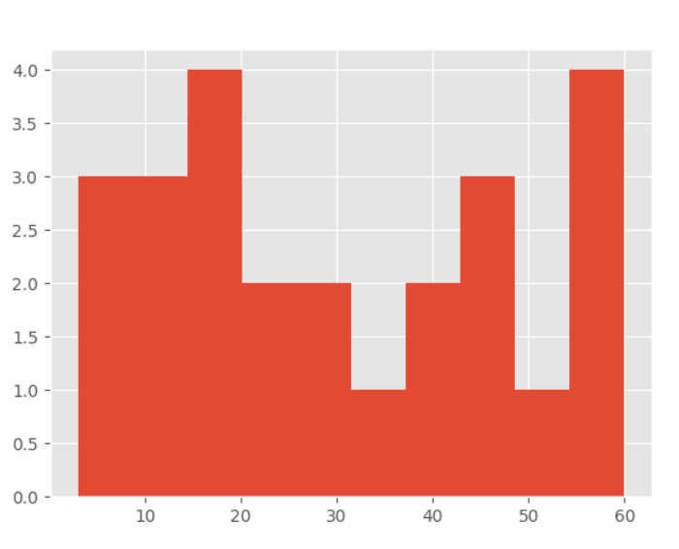

scatter plot

A scatter plot is a diagram where each value in the data set is represented by a dot.

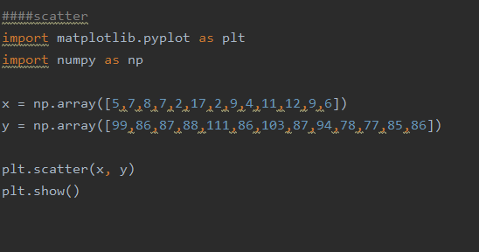

Output:

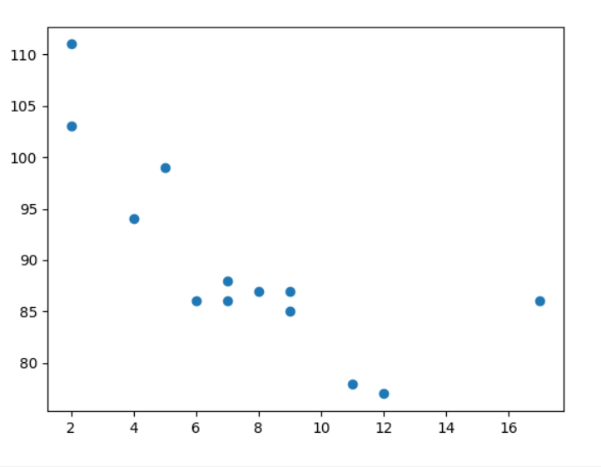

Pie chart

A pie diagram is a round factual realistic, which is isolated into cuts to represent mathematical extent. In a pie diagram, the bend length of each cut is corresponding to the amount it addresses.

code:

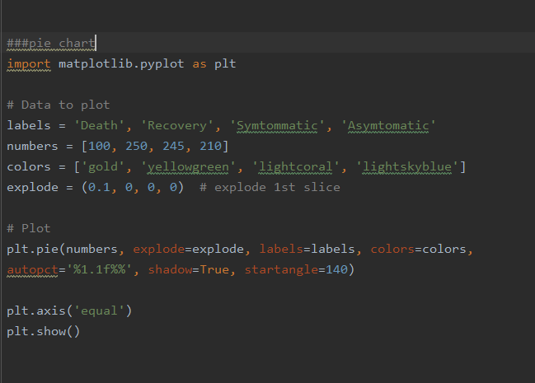

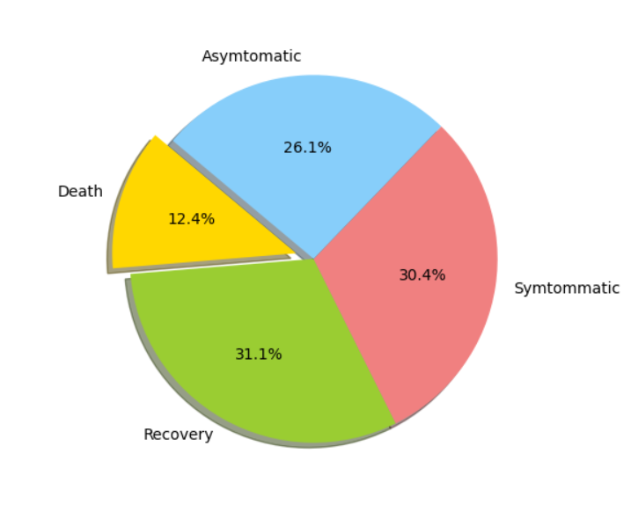

3D plot

3D plotting in Matplotlib begins by empowering the utility tool compartment. We can empower this tool compartment by bringing in the mplot3d library, which accompanies your standard Matplotlib establishment

code:

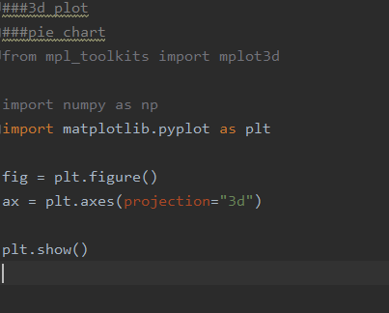

Output:

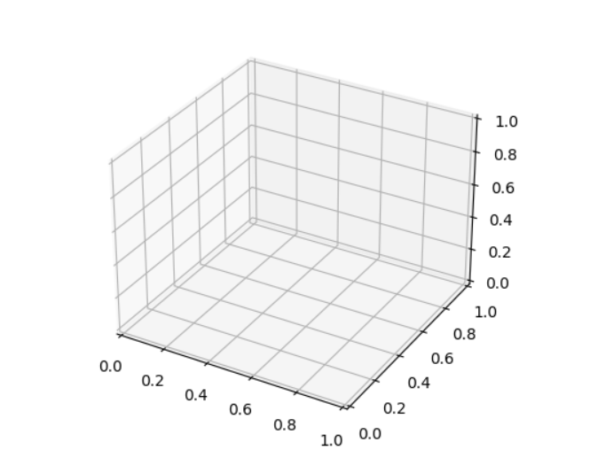

Question no. 8

**Implement a class in python and explain all the properties of a class using OOPs in python.**

Answer with code

In OOPs, each item is characterized by its properties. For instance, say our article is an Employee. These properties could be their name, age, and job. OOP makes it simple to display certifiable things and the connections between them. Numerous fledglings like to utilize OOP

1.class

Classes list the properties important to that type of object but do not assign them a value.

class never carries a value.

Classes additionally characterize strategies that are accessible to all objects of that sort.

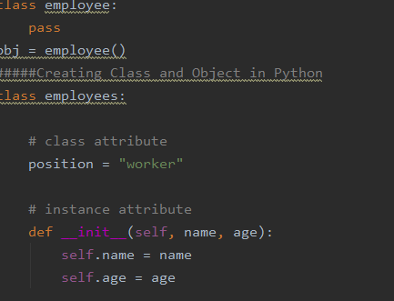

2.Object

An object is the instance of the class. At the point when class is characterized, just the portrayal of the object is characterized.

That is why no memory or storage is allocated.

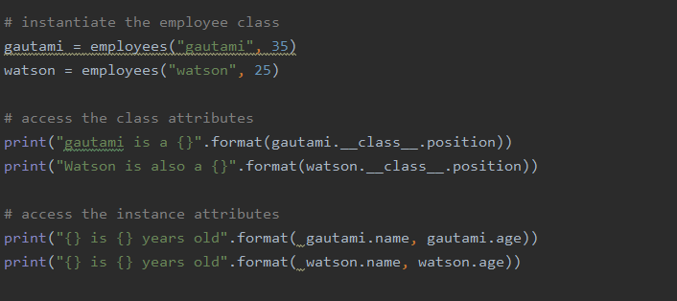

3.Methods

Methods are always listed inside the structure or body of the class.

They usually define the nature of the object.

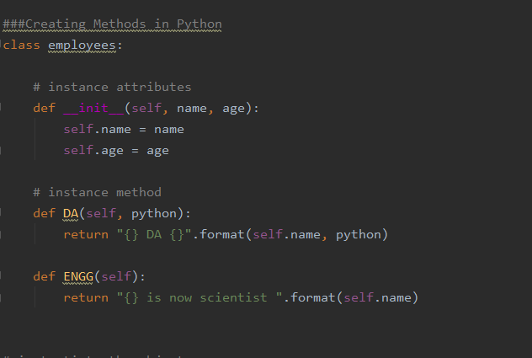

4.Inheritance

Inheritance always uses the old or existing class and on the behalf of that class new class is derived.

Thus the new class is called a child class and the existing class is called a parent class.

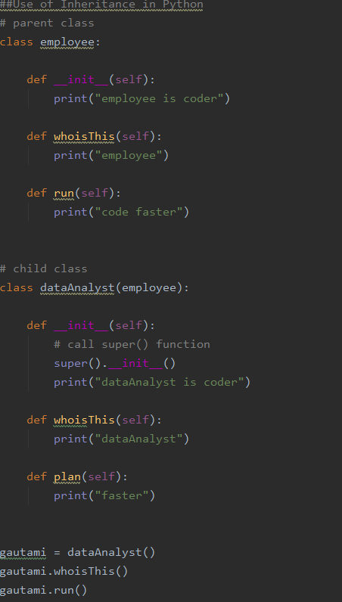

5.Encapsulation

When you use OOP in python, we do not need to use methods and variables which prevent data from direct modification is called encapsulation.

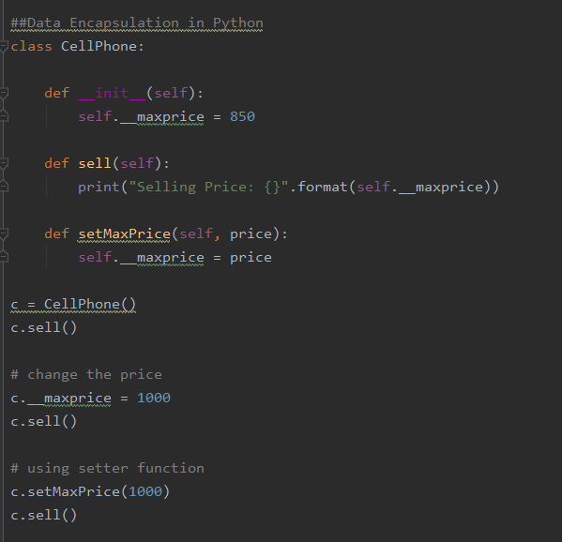

6.Polymorphism

Polymorphism has the potential to access a common interface for all data types.

example,

If we need colour a shape, we come across multiple shapes given as option but in polymorphism, you can use the same method to colour any shape is called polymorphism

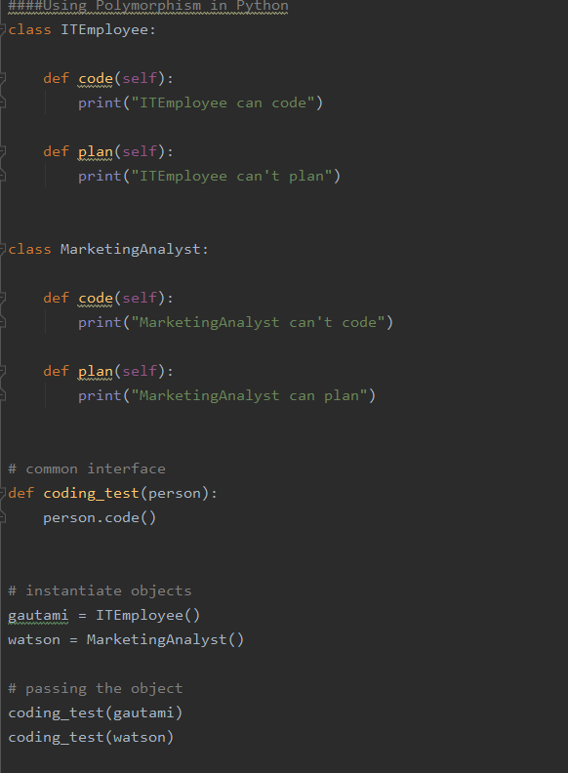

Conclusion:

Thus we come to the conclusion of this documentation.

Also, every code or script of given program will be mentioned in the GitHub repository.

Thankyou